ST-SC Optical Fibre Cable OM2

Overview
The 50/125µm OM2 multimode fiber optic cable is optically tested for insertion loss to ensure high quality. It is very cost-effective for network cabling in data centers, enterprise networks, telecom rooms, server farms, cloud storage networks, and any place where fiber patch cables are needed. OM2 patch cords are manufactured using LSZH cables and conform to IEC, EIA TIA or Telcordia standards.

Features
- Designed for Data Centers, Industry and Computer Centers
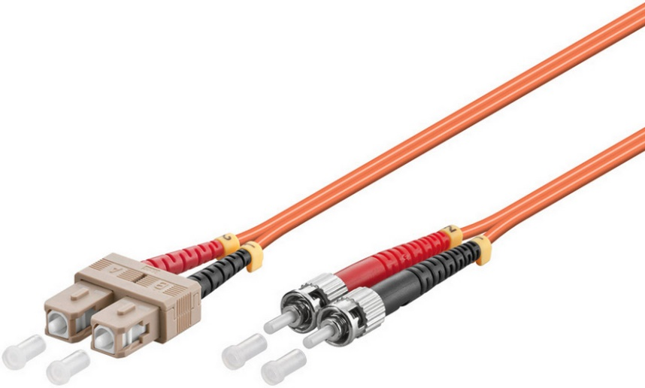
- LSZH (Low Smoke Zero Halogen) and flame retardant
- RoHS compliant

Technical Specification
Model | FIB1220XX-2 | Specs | 50/125µm OM2 multimode
Length | 0,5m,1m,2m,3m,5m,7m,10m,15m,20m,25m
Material | LSZH Cable
Shielding | Single shielded | Warranty | 30 Years
Common applications | For Data Centers, industry and computer centers. | Version | ST-SC Optical fibre Multimode duplex OM2 cable.
 |  | Testing | Tested before shipment
Colors | Orange | Packing | Clear plastic bag
 |  | Certifications | LSZH, RoHS
 |  | Installation and use | Plug and Play
 |  |  | Indoor

