ST-SC Optical Fibre Cable OM1

Overview
The 62.5/125µm OM1 multimode fiber optic cable is suitable for fast Ethernet, gigabit Ethernet and fiber channel applications, such as in data centers, telecom rooms, server farms, cloud storage networks and any place where fiber jumper cables are needed. OM1 patch cords are manufactured using LSZH cables which conform to IEC, EIA TIA or Telcordia standards.

Features
- Designed for Data Centers, Industry and Computer Centers
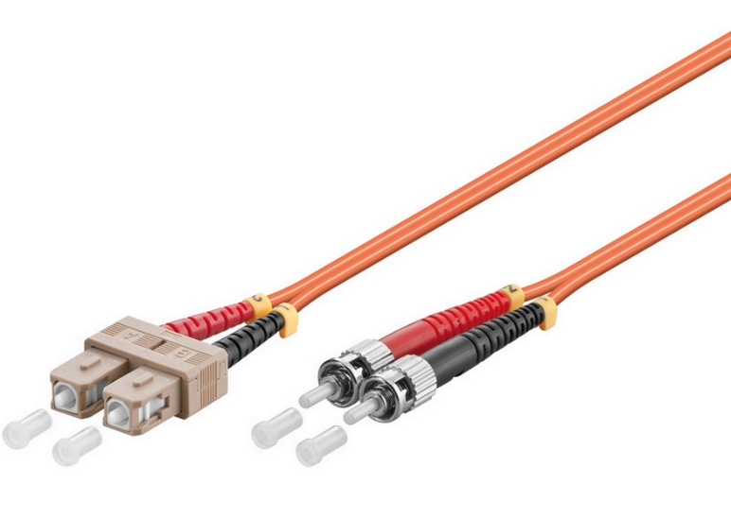
- LSZH (Low Smoke Zero Halogen) and flame retardant
- RoHS compliant

Technical Specification
Model | FIB1200XX | Specs | 62,5/125µm OM1 multimode
Length | 0,5m,1m,2m,3m,5m,7m,10m,15m,20m,25m
Material | LSZH Cable
Shielding | Single shielded | Warranty | 30 Years
Common applications | For Data Centers, industry and computer centers. | Version | ST-SC Optical fibre Multimode duplex OM1 cable.
 |  | Testing | Tested before shipment
Colors | Orange | Packing | Clear plastic bag
 |  | Certifications | LSZH, RoHS
 |  | Installation and use | Plug and Play
 |  |  | Indoor

