ST-ST Optical Fibre Cable OM4

Overview
OM4 patch cords are used to connect high speed and legacy networks like 10/40/100 gigabit ethernet, fast ethernet and ethernet. This 50/125 OM4 multimode fiber optic cable is ideal for connecting 40G BIDI SR, 10G SR, QSFP+, SFP+ transceivers etc. for 10G/40G/100G Ethernet connections and is the preferred fiber specification for 40G/100G applications. Multimode patch cords are manufactured using LSZH cable and conform to Telcordia, EIA TIA or IEC standards.

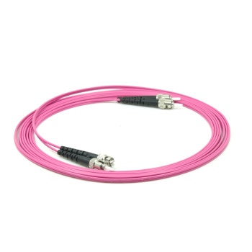
Features
- Designed for Data Centers, Industry and Computer Centers
- LSZH (Low Smoke Zero Halogen) and flame retardant
- RoHS compliant

Technical Specification
Model | FIB1120XX-4 | Specs | Supports speeds up to 10G/40G/100G
Length | 0,5m,1m,2m,3m,5m,7m,10m,15m,20m,25m
Material | LSZH Cable
Shielding | Single shielded | Warranty | 30 Years
Common applications | For Data Centers, industry and computer centers. | Version | ST-ST Optical fibre Multimode duplex OM4 cable.
 |  | Testing | Tested before shipment
Colors | Pink | Packing | Clear plastic bag
 |  | Certifications | LSZH, RoHS
 |  | Installation and use | Plug and Play
 |  |  | Indoor

