ST-ST Optical Fibre Cable OS2

Overview
Single mode fiber optic cable is suitable for enterprise network, Telecom rooms, server farms, cloud storage networks and any place where fiber jumper cables are needed. This cable is ideal for connecting 1G/10G/40G/100G Ethernet connections. It can transport data for up to 10km at 1310nm, or up to 40km at 1550nm. The single mode patch cords are manufactured using LSZH cables which conform to IEC, EIA TIA or Telcordia standards.

Features
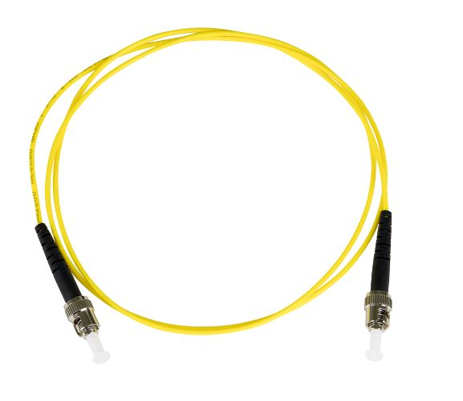
- Designed for Data Centers, Industry and Computer Centers
- LSZH (Low Smoke Zero Halogen) and flame retardant
- RoHS compliant

Technical Specification
Model | FIB1110XX | Specs | Supports speeds up to 1G/10G/40G/100G
Length | 0,5m,1m,2m,3m,5m,7m,10m,15m,20m,25m
Material | LSZH Cable
Shielding | Single shielded | Warranty | 30 Years
Common applications | For Data Centers, industry and computer centers. | Version | ST-ST Optical fibre Singlemode duplex OS2 cable.
 |  | Testing | Tested before shipment
Colors | Yellow | Packing | Clear plastic bag
 |  | Certifications | LSZH, RoHS
 |  | Installation and use | Plug and Play
 |  |  | Indoor

