LC-SC Optical Fibre Cable OM5

Overview
Due to the demand of the continuously increasing bandwidth, the fiber patch cables also has updated quality. The latest version is Multimode OM5, also known as WBMMF (WideBrand MultiMode Fiber). This is made to meet the growing bandwidth requirements.

Features
- Designed for Data Centers, Industry and Computer Centers
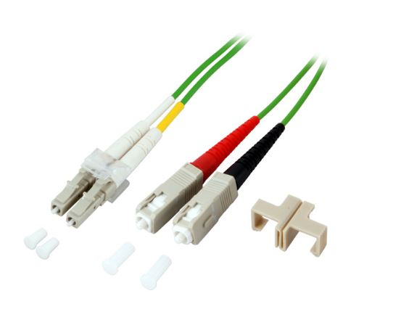
- LSZH (Low Smoke Zero Halogen) and flame retardant
- RoHS compliant

Technical Specification
Model | FIB5610XX | Specs | 50/125µm OM5
Length | 0,5m,1m,2m,3m,5m,7m,10m,15m,20m,25m
Material | LSZH Cable
Shielding | Single shielded | Warranty | 30 Years
Common applications | For Data Centers, industry and computer centers. | Version | LC-SC Optical fibre Multimode duplex OM5 cable.
 |  | Testing | Tested before shipment
Colors | Green | Packing | Clear plastic bag
 |  | Certifications | LSZH, RoHS
 |  | Installation and use | Plug and Play
 |  |  | Indoor

