LC-SC Optical Fibre Cable OM4

Overview
The 50/125µm OM4 multimode bend insensitive fiber optic cable is less attenuation when bent or twisted compared with traditional optical fiber cables and this will make the installation and maintenance of the fiber optic cables more efficient. This 50/125 OM4 multimode fiber optic cable is ideal for connecting 10G SR, 10G LRM, SFP+ transceivers etc. for 10G/40G/100G Ethernet connections and is the preferred fiber specification for 10G Ethernet connections. The multimode patch cords are manufactured using LSZH cables which conform to IEC, EIA TIA or Telcordia standards.

Features
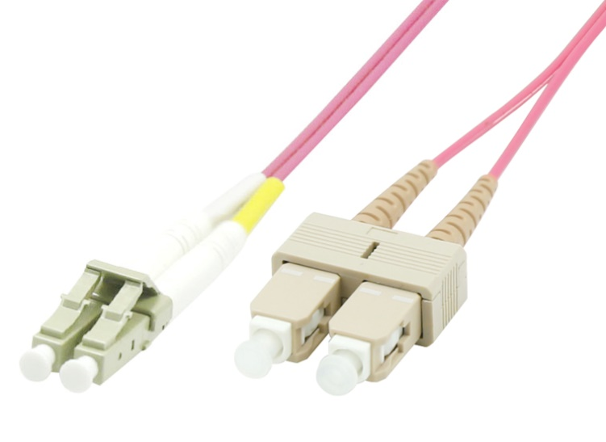
- Designed for Data Centers, Industry and Computer Centers
- LSZH (Low Smoke Zero Halogen) and flame retardant
- RoHS compliant

Technical Specification
Model | FIB4220XXP | Specs | Supports speeds up to 10G/40G/100G
Length | 0,5m,1m,2m,3m,5m,7m,10m,15m,20m,25m
Material | LSZH Cable
Shielding | Single shielded | Warranty | 30 Years
Common applications | For Data Centers, industry and computer centers. | Version | LC-SC Optical fibre Multimode duplex Om4 cable.
 |  | Testing | Tested before shipment
Colors | Pink | Packing | Clear plastic bag
 |  | Certifications | LSZH, RoHS
 |  | Installation and use | Plug and Play
 |  |  | Indoor

