Premium USB3.2 100W cable

Overview
With this Premium MicroConnect USB-C cable you can now go all-in with a fully specced Gen2 USB-C cable, capable of 20Gbps data transfers, 100W of Power Delivery, 20V/5A of Fast-Charging performance, and even 3840x2160p Ultra HD 4K video output at 60Hz! It's amazing and it's all here in this cable.
This USB 3.2 Cable (Type-C Male to Male) connects between two USB Type-C devices for the fastest possible data transfer and charging rates available. Precision data transfers and power delivery mean this cable supports PD100W for 100W of Power Delivery charging - perfect for charging hungry USB devices. With this cable you can enjoy 20Gbps data transfers, up to 5A of charging power, and an unprecedented 100W for power delivery.
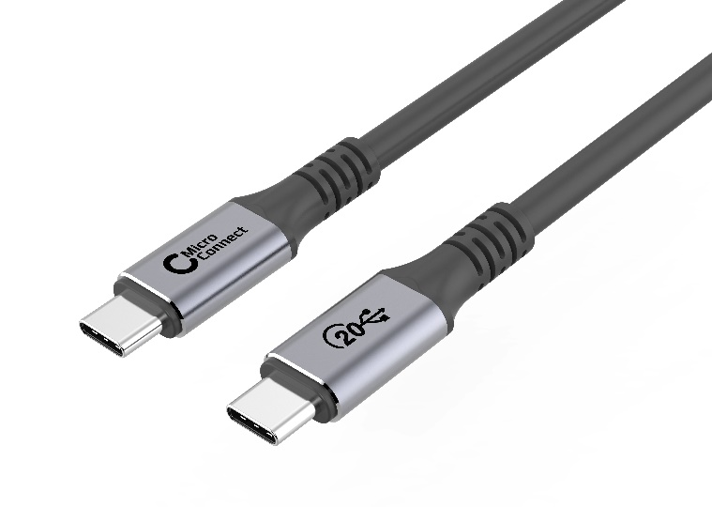
Features
- Up to 100W Power delivery
- Up to 20Gbps data transfer
- Supports resolutions at up to 4k60Hz
- Soft TPE Jacket

Technical Specification

Model | USB3.2CCX | Specs | Supports up to 3840x2160p 60Hz
Length | 2m,3m,4m,5m
Material | Soft TPE Cable
Shielding | Single shielded | Warranty | 30 Years
Common applications | For signal between computer / notebook and monitor. | Version | USB version 3.2
 | AV installations
 |  | Testing | Tested before shipment
Colors | Black | Packing | MicroConnect Polybag
 |  | Certifications | CE, Reach, RoHs
 |  | Installation and use | Plug and Play
 |  |  | Indoor

